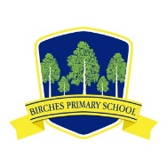
Birches Primary School

Good morning boys and girls,
I just wanted to let you know that we all miss you and are thinking about you. Thank you for all of the hard work you have been doing on seesaw and with the work your teachers have set for you in your home learning pack. They have shown me some of your lovely work and drawings which I think are fabulous! I have seen photographs of different things you have been doing at home, from baking buns, to climbing trees and playing outside. I have also really loved reading the emails some of you and your parents have sent me.

I know this is a very difficult time for you all as you miss seeing your friends and family and getting out to play and visit different places, but we all have to help keep everyone whom we love safe by staying at home.

I am very proud of you for being so good and working so hard for your parents. Today is our last day of term and over the next couple of weeks we are taking our Easter holidays so you don’t have any school work to do!
Your teachers will be in touch with you and your parents about work in the summer term which starts again on Monday 20 April.

I hope everyone is able to enjoy their time at home and keep safe.
Thinking about you,

Mrs Watson

