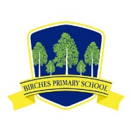
Birches Primary School

School Closure Information - 18th Mar 2020

Dear Parents,

I have attached a letter from the Education Minister regarding the closing of schools in Northern Ireland. It has been indicated that the closure may extend to the summer holidays.

The establishment of ‘Hub Schools’ has been mentioned on the news, but so far there has been no further detail regarding this.

Staff have sent home an initial Home Learning Pack with work up to the Easter holidays.
Home learning arrangements are being put in place for the period following that.

This is obviously going to be a very different type of learning experience for all of us and not without challenges. It is at a time like this when we need to work together and support each other - albeit at a distance! We will all miss the daily contact which we have, not only the children but with our parents, grandparents and people we see on a regular basis.

On behalf of the staff and governors at Birches Primary school we hope everyone keeps safe and well.

Yours sincerely,
Patricia Watson

