Social distancing essential in battle against coronavirus

Friday, 20 March 2020
Health Protection
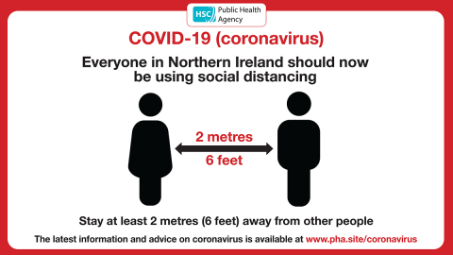

The Public Health Agency (PHA) is urging people to follow the advice on social distancing as an essential part of slowing the spread of coronavirus (COVID-19) and saving lives.
Dr Hugo Van Woerden, Director of Public Health at the PHA, said: “I cannot emphasise enough how important it is to practise social distancing as a key step in saving lives. The guidance to socially distance ourselves from others applies to everyone. We should all be taking steps to reduce social interaction between people in order to reduce the transmission of coronavirus.
“Every one of us has a role to play in this battle.”
Key steps
- While it is important to avoid contact with anyone who is displaying symptoms of COVID-19, including a high temperature and/ or new and continuous cough, we may not know if a person has the virus (including ourselves) therefore we should practise social distancing with everyone.
- It is also advised that we avoid non-essential use of public transport, varying our travel times to avoid rush hour when possible.
- People should work from home, where possible. Your employer should support you to do this.
- We should all be avoiding large gatherings, and gatherings in smaller public spaces such as pubs, cinemas, restaurants, theatres, bars, and clubs, and avoid gatherings with friends and family.
“We understand that this will be difficult, particularly with Mother’s Day this weekend for example, so it is worth looking at keeping in touch using your phone, the internet, and social media,” said Dr Van Woerden.
“If you are outdoors, stay more than two metres (six feet) away from others.
“As part of the effort to reduce the spread, only use the phone or online facilities to contact your GP or other essential services.
“Everyone should be trying to follow these measures as much as is practicable.
“We strongly advise you to follow the above measures as much as you can and to significantly limit your face-to-face interaction with friends and family if possible, particularly if you: are over 70, have an underlying health condition, or are pregnant.”
The latest information and advice on coronavirus is available at www.pha.site/coronavirus
Looking after your wellbeing
You may find that social distancing can be boring, frustrating or lonely and that your mood and feelings are affected. You may feel low, worried or have problems sleeping and you might miss being with other people.
At times like these, it can be easy to fall into unhealthy patterns of behaviour which in turn can make you feel worse. However, there are simple things you can do that may help.
Dr Van Woerden said: “While adhering to the social distancing guidance, it is also essential to stay mentally and physically active during this time.
“Look for ideas of exercises you can do at home on the PHA’s website at www.choosetolivebetter.com, where you can also find healthy recipes – try to eat healthy, well-balanced meals, drink enough water, exercise regularly, and try to avoid smoking, alcohol and drugs.
“Do things you might enjoy such as reading, cooking and other indoor hobbies, or listening to the radio or watching TV programmes. You can access free audiobooks and e-books though the Libraries NI website at www.librariesni.org.uk
“Keep your windows open to let in fresh air, get some natural sunlight if you can, or get outside into the garden.
“You can also go for a walk outdoors if you stay more than two metres (six feet) from others.”
For tips and advice on looking after your mental wellbeing, visit www.mindingyourhead.info

