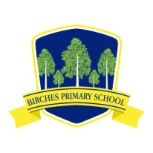
Birches Primary School

Information regarding support from Parentline NI

Dear Parents,

Parentline NI have asked me to share their Regional Parents Helpline which is in full operation throughout this period. They can be contacted on freephone 0808 8020 400 to provide advice, support and guidance to parents and carers.
Opening times:
Monday- Thursday 9am-9pm
Friday 9am-5pm
Saturday 9am-1pm

You can also contact them via webchat www.ci-ni.org.uk or email parentline@ci-ni.org.uk

