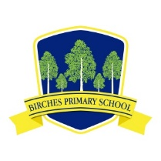
Birches Primary School

SAFER SCHOOLS APP
Information for Parents and Staff

The Department of Education has launched a new app on the Safer Schools platform which has been provided by iNEQE Safeguarding Group on a trial basis during this COVID-19 crisis.
The app is currently used widely across the rest of the UK.
The app, downloaded on either the App Store or Google Play, can be accessed by professionals and by parents/carers.
When you download the App, you will need a QR code which is
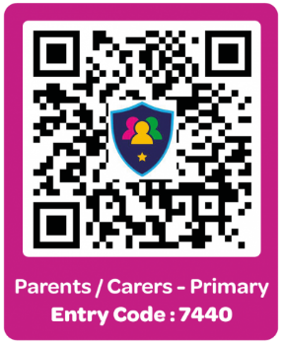

For further information you can go to the ‘Landing page’
https://ineqe.com/safer-schools-ni/

I hope everyone is keeping safe and well,
Mrs Watson

